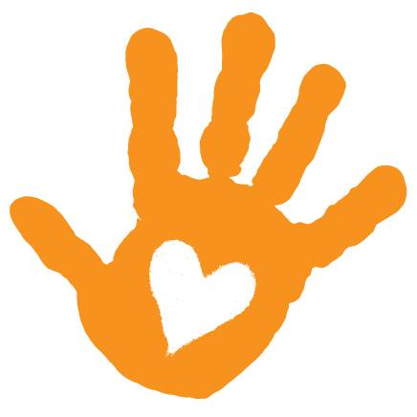

This year we would like to provide an alternative to bringing a gift for Addie’s birthday. As many of you know, Kelli and Addie are involved in a wonderful non-profit organization called, Little Hands Can. Addie has already performed close to two dozen community service projects. She has gotten a lot of joy out of helping others. She still talks about many of them! With Christmas on the horizon and the fact that Addie is already blessed with more toys than time in the day, we thought that it would be great if you would join us for one of the great activities we have planned. If you would prefer to sponsor these activities, we would love that too! Here are some of the things we will likely do over the next year.

Community clean-up day

Food bank collection

Work in a food kitchen (donate food, too!)

Folsom Zoo clean-up day

Donate candy to Operation Shoebox

Make paper snowflakes for the senior center

Visit an animal sanctuary and volunteer

Collect and donate supplies to Project R.I.D.E

Make and deliver Shamrock cookies to firefighters

Host at least 2 community service play dates

To join an activity: Email <insert email address> with your interest.

To sponsor an activity: Donations can be made at [www.littlehandscan.org](http://www.littlehandscan.org) or you can provide a check made out to Little Hands Can. You will receive a signed donation letter from Addison. All donations are tax deductible. 100% of donated funds will be set aside for Addie’s activities.

Kelli will be sending out a monthly newsletter which will include pictures and a story about Addie’s community service involvement for the month. Let Kelli know if you would like to receive a copy!

Thank you so much!

(If it’s important to you that Addie receive a gift please disregard this) ☺



This year we would like to provide an alternative to bringing a gift for Addie’s birthday. As many of you know, Kelli and Addie are involved in a wonderful non-profit organization called, Little Hands Can. Addie has already performed close to two dozen community service projects. She has gotten a lot of joy out of helping others. She still talks about many of them! With Christmas on the horizon and the fact that Addie is already blessed with more toys than time in the day, we thought that it would be great if you would join us for one of the great activities we have planned. If you would prefer to sponsor these activities, we would love that too! Here are some of the things we will likely do over the next year.

Community clean-up day

Food bank collection

Work in a food kitchen (donate food, too!)

Folsom Zoo clean-up day

Donate candy to Operation Shoebox

Make paper snowflakes for the senior center

Visit an animal sanctuary and volunteer

Collect and donate supplies to Project R.I.D.E

Make and deliver Shamrock cookies to firefighters

Host at least 2 community service play dates

To join an activity: Email <insert email address> with your interest.

To sponsor an activity: Donations can be made at [www.littlehandscan.org](http://www.littlehandscan.org) or you can provide a check made out to Little Hands Can. You will receive a signed donation letter from Addison. All donations are tax deductible. 100% of donated funds will be set aside for Addie’s activities.

Kelli will be sending out a monthly newsletter which will include pictures and a story about Addie’s community service involvement for the month. Let Kelli know if you would like to receive a copy!

Thank you so much!

(If it’s important to you that Addie receive a gift please disregard this) ☺